Esther Becomes Queen
Esther 1:1 - 2:18

Main Point: God is Sovereign. He is in control of all things.

Key Verse: The king’s heart is in the hand of the Lord. He directs it like a stream of water anywhere He pleases. Proverbs 21:1

Craft Ideas

Esther’s Crown
Gold Crowns Oriental Trading 25/105
Self Adhesive Jewels Oriental Trading 48/2089
- Print Key Verse onto sticker address labels, Avery #5160.
- Decorate crown with adhesive-backed jewels, glitter, markers and additional decorative stickers.
- Apply Key Verse sticker to back of finished crown.

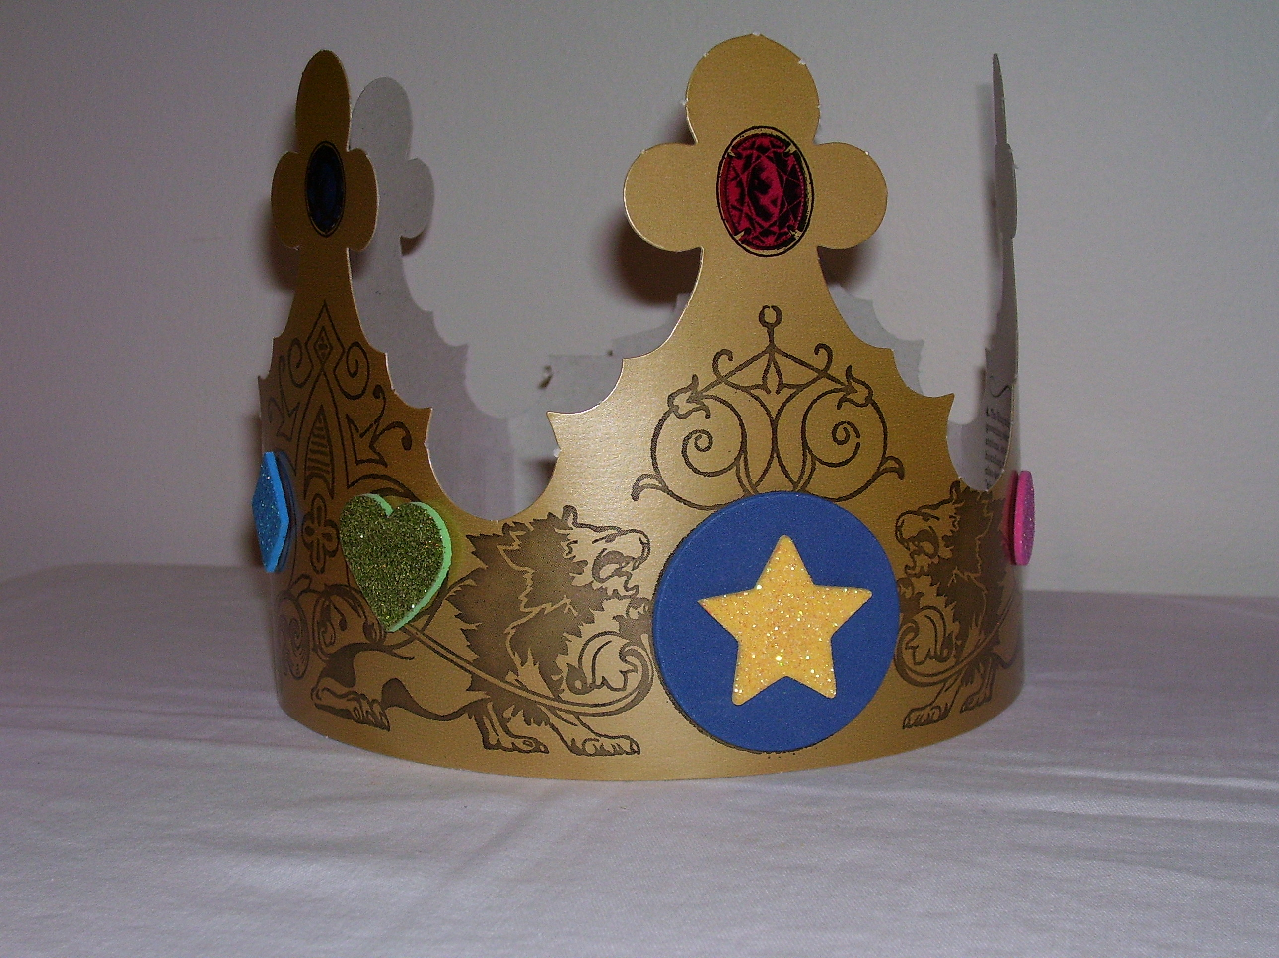

“Esther’s Crown” Magnet
Needed Supplies: Crown shape, Large star shape, jewel stickers, glue stick, spray glitter, magnet.
- Apply jewel stickers to crown.
- Glue crown to star shape that has been sprayed with spray glitter.
- Apply Key Verse to “Esther’s Crown” craft.
- Add a magnet to back of finished craft.



